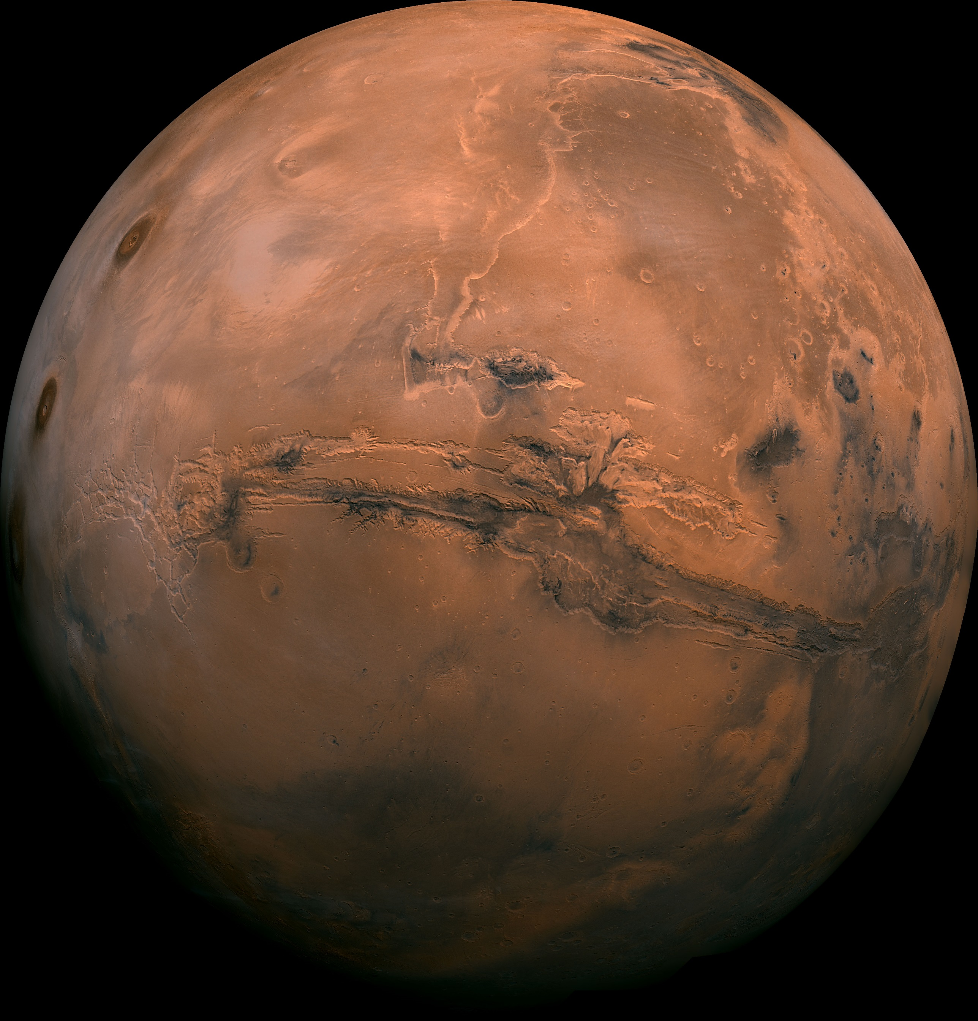

**C:\Users\CALDJA3\Desktop\196y6gmiemutvpng.pngA Princess of Mars**

Edgar Rice Burroughs